Ventura County oil sector poised for growth in 2018 and beyond
By Tony Biasotti / Friday, May 11th, 2018 / No Comments
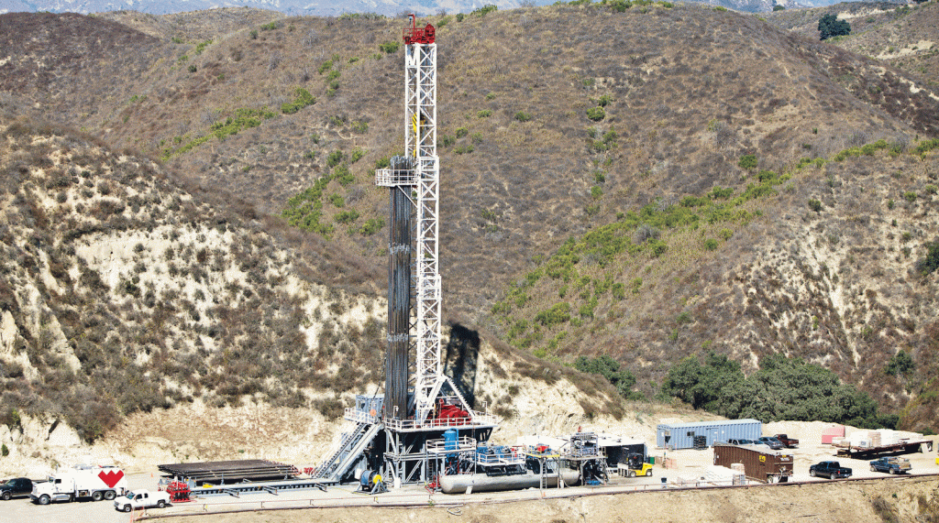
An Aera Energy oil well in the Ventura Field in west Ventura. With oil prices climbing, Ventura County oil production is expected to rise.
Oil and gas production in Ventura County likely bottomed out in 2017 and will grow in 2018 and beyond, especially if the Trump administration’s decision to withdraw from the Iran nuclear pact continues to drive oil prices higher.
The oil and gas industry accounts for more than 2,000 jobs in Ventura County, many of them highly paid blue-collar jobs, and will pay around $56 million in state and local taxes this year, according to a recent study.
The study was conducted by the Sacramento research and consulting firm Capitol Matrix Consulting and commissioned by Californians for Energy Independence, which is funded largely by oil and gas interests.
If the price of oil falls within the ranges predicted by the World Bank and other experts, production, employment and tax revenue in Ventura County should increase over the next five years. In 2023, the industry is projected to generate more than 3,000 jobs and $76 million in state and local taxes; with oil prices jumping past $70 per barrel in the wake of the administration’s May 8 decision to walk away from the Iran accord, the impact could be even greater.
While the numbers aren’t that big in the context of Ventura County’s 300,000 nonfarm jobs, or in the context of its government budgets, which total in the billions, they are significant at a time when high paying jobs in manufacturing and at biotech giant Amgen are shrinking.
While the economic output of the oil and gas production industry accounts for a little less than 1 percent of the gross county product, Ventura County does have the largest oil and gas sector in the tri-county region. In 2016, the county produced 7.7 million barrels of oil, a little over 4 percent of the state total and behind only Kern, Los Angeles and Monterey counties, according to the California Department of Conservation’s Division of Oil, Gas and Geothermal Resources.
Ventura County also ranked fifth among California counties in natural gas production.
It’s the quality, if not the quantity, of the industry’s jobs that matter. The average wage in 2016 of the 771 people directly employed in oil extraction, pipeline construction and other support jobs was $99,092, according to the Capitol Matrix report.
“People with high school degrees can make a middle-class living, and that’s becoming rarer and rarer in California, and everywhere,” said Brad Williams, a partner at Capitol Matrix and the report’s lead author. “Outside of Silicon Valley, you don’t see whole industries that pay $100,000 a year on average.”
The big variable in the Capitol Matrix report is the price of crude oil, since oil companies produce more when they can get paid more for the product. The report assumes slight increases in oil prices, from $60 per barrel in 2018 to $70 per barrel by 2023.
Prices are already outstripping those projections; on May 7, crude oil hit $70 per barrel for the first time since 2014.
“A pickup in investment, and hence jobs and income and economic output, is very much dependent on oil prices recovering from where they were in 2016 and 2017, which was kind of historically low,” Williams said.
Before that price dip, the industry had been growing. In 2014, when prices were above $100 per barrel, total employment directly and indirectly tied to oil and gas production was 48 percent higher than the current level, and local and state tax revenues were 59 percent higher.
Drilling in Ventura picks up when the price of oil rises, but the big-picture trend, spanning more than 60 years, is one of decline. In the 1950s, the Ventura Field, the biggest oil field in the county, produced more than 30 million barrels per year. By the early 1980s, production had dropped to 17.3 million barrels, and by 2005, it was down to 7 million barrels.
Price is one reason; oil prices dropped significantly through most of the 1980s and 1990s. Technology and geology were factors; with the extraction methods available in the 1980s, the Ventura Field couldn’t produce as much oil as it had in the 1950s.
Regulation is another reason for the industry’s long-term decline, said Bob Poole, director of production and state and coastal issues for the Western States Petroleum Association.
“It’s a clear case of California making decisions to limit the supply that’s produced here and encourage more oil and gas to be produced elsewhere and imported here,” he said.
In the eyes of many environmentalists, those regulatory changes haven’t gone far enough. Citizens For Responsible Oil and Gas is a Ventura County group that lobbies state and local governments for tighter regulations on drilling in the area.
Kimberly Rivers, CFROG’s executive director, said she has no quarrel with the Capitol Matrix report’s general assessment of the industry or its predictions for the next five years. She’s worried, though, about what happens after 2023. If the trend toward solar and other green technologies continues, and electric vehicles reach a tipping point among consumers, the long-term outlook will be much different.
Local leaders should start thinking now about how to replace some of the jobs in the oil and gas industry and how to retrain its workers, Rivers said.
“I think the county needs to wean itself off of exactly what this report is saying,” she said. “The economic benefit the county gets from this industry is going to dwindle over time. … There’s going to be a transition away from fossil fuels over the next half century. Wouldn’t it be responsible to start preparing for that now?”
Oil company representatives say they’re preparing for that future, though they see oil and gas as a major part of the energy supply for decades to come. The U.S. Energy Information Administration projects that oil consumption will be about the same in 2040 as it was in 2016, with use of renewables and natural gas rising to fill the increase in demand.
“We should be looking at an all-in energy policy,” said Michele Newell, a public affairs coordinator for Aera Energy. Aera, jointly owned by Shell Oil and ExxonMobil, is the largest production company in Ventura County. It owns the Ventura Field, off of Ventura Avenue, which accounts for more than half of the oil produced in the county.
“Oil and gas is steady and reliable, and we can produce it responsibly in California,” Newell said. “We know that in order to operate in California, we have to operate safely and sustainably.”

